RUNNING THE CRANIOBOT:

All Craniobot software is in the Craniobot folder on the windows desktop, the google dirve G:\Shared drives\TNEL - UMN\Project related material\craniobot, and on GITHUB.

To start run CaniobotGUI.py

All the commands you need to run the Caniobot are iconified on the screen.

1. Using the trident stereotaxic leveling tool, be sure the rodent skull is level.
2. Select Species. Currently only Rats or Mice are available.
3. 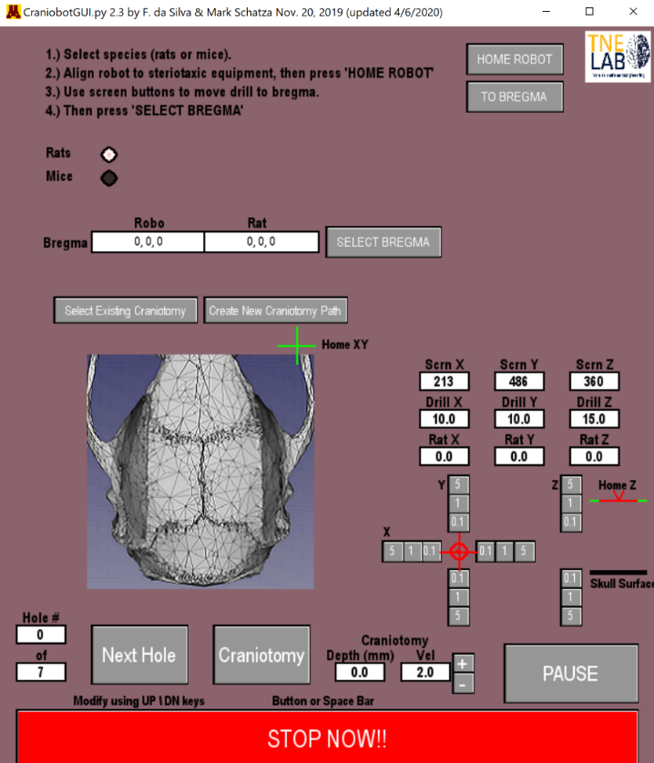Align the Craniobot with the stereotaxic equipment. This is done by pushing the Craniobot snuggly against the right side of the stereotaxic equipment. Taping it down to the table is also recommended.

Remember the robot only has a 2.5 cm range of motion along each axis. It is therefore desirable that the tip of the drill is roughly at the bregma when the robot X,Y,Z is at approximately (12.5 , 12.5, 12.5). Though X,Y,Z = 10, 10, 10 is perfectly adequate for most surgeries.

**Best Practice:** Home the robot. The use the XYZ buttons to move the robot to approximately X,Y,Z = 10, 10 , 10. Move the entire robot assembly so that the drill is just above the Bregma. Note: The drill bit most likely can NOT be inserted entirely into the drill, rather let it stick out about 3 cm so that it just touches the skull when Z is approximately 10 to 20 cm.

1. When the robot assembly is aligned to the stereotaxic equipment and the robot is approximately in the middle of its working volume (~10, ~10, ~ 10), use the XYZ move buttons to touch the drill precisely to the Bregma. The press the SELECT BREGMA button. You should see a red circle and cross-hairs over the bregma graphic.
2. Select an Existing Craniotomy or Create New Craniotomy Path. Any pre-existing craniotomy path can be edited using the Craniotomy Designer stand alone application by pressing the Create New Craniotomy Path button.
3. Be sure drill is ON and going in the FWD direction.
4. **CRANIOTOMY:** Press Craniotomy button. One pass of the entire craniotomy path depicted in the screen graphics will be reproduced by the robot.
5. Repeat Step 5. On each pass, the drill will cut the path 0.1 mm deeper. Repeat until through skull (approximately 10 passes). NOTE: The craniobot assumes that the rodent skull is level.
6. **SCREW HOLES:** Next press Next Hole Button to create screw holes.